RecentGraduatesAnalysis
Charles Kirk
2024-09-20
library(tidyverse)
## ── Attaching core tidyverse packages ──────────────────────── tidyverse 2.0.0 ──
## ✔ dplyr 1.1.4 ✔ readr 2.1.5
## ✔ forcats 1.0.0 ✔ stringr 1.5.1
## ✔ ggplot2 3.5.1 ✔ tibble 3.2.1
## ✔ lubridate 1.9.3 ✔ tidyr 1.3.1
## ✔ purrr 1.0.2
## ── Conflicts ────────────────────────────────────────── tidyverse_conflicts() ──
## ✖ dplyr::filter() masks stats::filter()
## ✖ dplyr::lag() masks stats::lag()
## ℹ Use the conflicted package (<http://conflicted.r-lib.org/>) to force all conflicts to become errors
recent_grads <- read_csv("~/Dropbox/Charley/Juniata/Data Science Masters/Data Mining/recent-grads.csv")
## Rows: 173 Columns: 21
## ── Column specification ────────────────────────────────────────────────────────
## Delimiter: ","
## chr (2): Major, Major_category
## dbl (19): Rank, Major_code, Total, Sample_size, Men, Women, ShareWomen, Empl...
##
## ℹ Use `spec()` to retrieve the full column specification for this data.
## ℹ Specify the column types or set `show_col_types = FALSE` to quiet this message.
recent_grads%>%
glimpse()
## Rows: 173
## Columns: 21
## $ Rank <dbl> 1, 2, 3, 4, 5, 6, 7, 8, 9, 10, 11, 12, 13, 14, 15…
## $ Major_code <dbl> 2419, 2416, 2415, 2417, 2405, 2418, 6202, 5001, 2…
## $ Major <chr> "PETROLEUM ENGINEERING", "MINING AND MINERAL ENGI…
## $ Major_category <chr> "Engineering", "Engineering", "Engineering", "Eng…
## $ Total <dbl> 2339, 756, 856, 1258, 32260, 2573, 3777, 1792, 91…
## $ Sample_size <dbl> 36, 7, 3, 16, 289, 17, 51, 10, 1029, 631, 399, 14…
## $ Men <dbl> 2057, 679, 725, 1123, 21239, 2200, 832, 2110, 129…
## $ Women <dbl> 282, 77, 131, 135, 11021, 373, 960, 1667, 2105, 6…
## $ ShareWomen <dbl> 0.1205643, 0.1018519, 0.1530374, 0.1073132, 0.341…
## $ Employed <dbl> 1976, 640, 648, 758, 25694, 1857, 2912, 1526, 764…
## $ Full_time <dbl> 1849, 556, 558, 1069, 23170, 2038, 2924, 1085, 71…
## $ Part_time <dbl> 270, 170, 133, 150, 5180, 264, 296, 553, 13101, 1…
## $ Full_time_year_round <dbl> 1207, 388, 340, 692, 16697, 1449, 2482, 827, 5463…
## $ Unemployed <dbl> 37, 85, 16, 40, 1672, 400, 308, 33, 4650, 3895, 2…
## $ Unemployment_rate <dbl> 0.018380527, 0.117241379, 0.024096386, 0.05012531…
## $ Median <dbl> 110000, 75000, 73000, 70000, 65000, 65000, 62000,…
## $ P25th <dbl> 95000, 55000, 50000, 43000, 50000, 50000, 53000, …
## $ P75th <dbl> 125000, 90000, 105000, 80000, 75000, 102000, 7200…
## $ College_jobs <dbl> 1534, 350, 456, 529, 18314, 1142, 1768, 972, 5284…
## $ Non_college_jobs <dbl> 364, 257, 176, 102, 4440, 657, 314, 500, 16384, 1…
## $ Low_wage_jobs <dbl> 193, 50, 0, 0, 972, 244, 259, 220, 3253, 3170, 98…
recsub<-recent_grads%>%
select(Rank, Major, Major_category, Total, Sample_size, Men, Women, ShareWomen, Full_time_year_round, Median, P25th, P75th, College_jobs, Non_college_jobs, Low_wage_jobs)
recent_grads%>%
mutate(Fullpart=Full_time+Part_time, Totminunem=Total-Unemployed, Colnoncol=College_jobs+Non_college_jobs)%>%
select(Employed, Fullpart, Totminunem, Colnoncol)%>%
filter(Employed<Colnoncol)
## # A tibble: 0 × 4
## # ℹ 4 variables: Employed <dbl>, Fullpart <dbl>, Totminunem <dbl>,
## # Colnoncol <dbl>
recsub%>%
mutate(Colprop=College_jobs/(College_jobs+Non_college_jobs), Lowprop=Low_wage_jobs/Total)%>%
select(ShareWomen, Colprop, Lowprop)%>%
pairs()
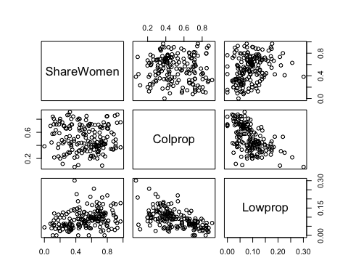
recsub%>%
mutate(Colprop=College_jobs/(College_jobs+Non_college_jobs), Lowprop=Low_wage_jobs/Total)%>%
select(ShareWomen, Colprop, Lowprop)%>%
pairs()+
theme(axis.title = element_text(size = 40), axis.text.x = element_text(angle = 90, size=30), axis.text.y = element_text(size = 30), legend.title = element_text(size = 40), legend.text = element_text(size = 30), legend.position = "bottom", strip.text = element_text(size = 40))

## NULL

